

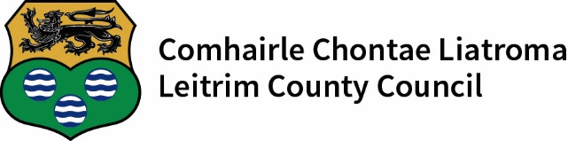

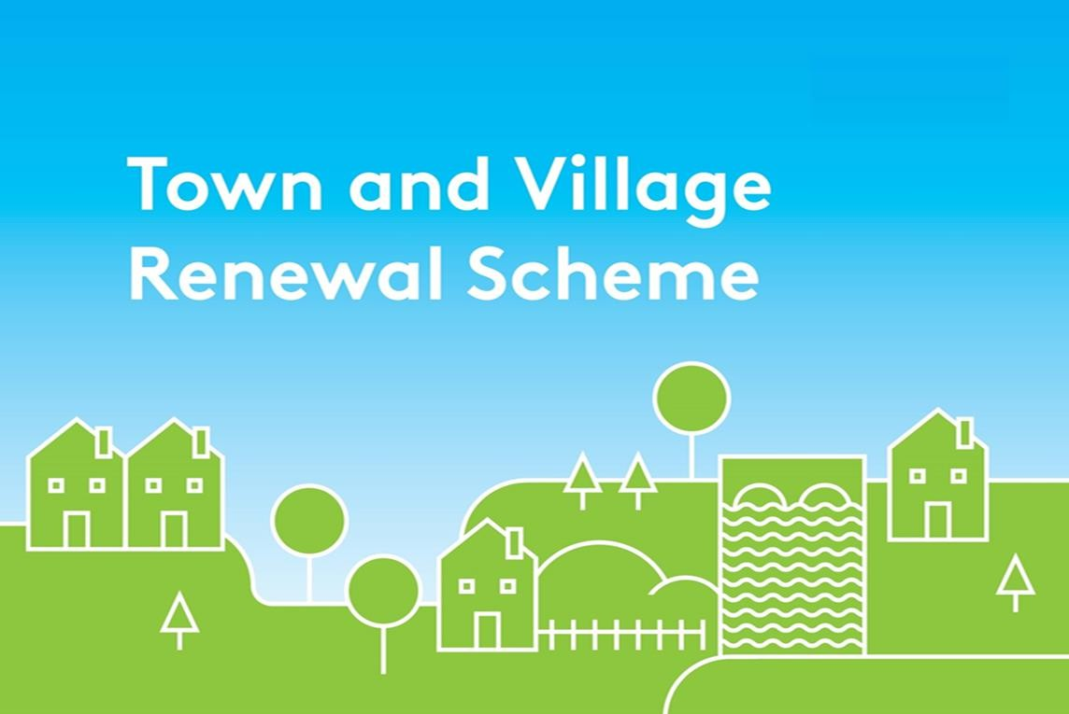

Town and Village Renewal Scheme 2026
Call for Expressions of Interest
All queries should be emailed to: funding@leitrimcoco.ie

Further information is available at
: (071) 9620005 Ext 474
: funding@leitrimcoco.ie

Contents
- Overview of the 2026 Scheme 3
- Main Scheme Grant Level Available 5
- Categories of Towns 6
- Application, Assessment and Approval Process 7
- Types of Activities Supported 8
- Types of Activities not supported 10
- Funding Conditions 11
- Application Scoring Framework 13
- Appendix 1 – Hub Classification Guide 15

___________________________________________________________________________________________________________________
Introduction
Funded under Project Ireland 2040, the Town and Village Renewal Scheme (TVRS) is a key measure directly supporting the objectives of Our Rural Future and the Town Centre First (TCF) Policy. The Scheme which was introduced in 2016, is part of a suite of measures designed to rejuvenate rural towns and villages throughout Ireland.

The National Planning Framework (NPF) sets the vision and strategy for the development of our country, balanced across all of our regions, towns and cities, out to the year 2040. The Department of Rural and Community Development and the Gaeltacht strives to support the enhancement of vibrant, inclusive and sustainable communities throughout Ireland. The Department supports NPF commitments through targeted policy and investment that empowers communities, supports sustainable rural regeneration and fosters regional growth.

Our Rural Future 2026-2031 Public Consultation Document commits to supporting a thriving rural Ireland. This is integral to our national economic, social, cultural and environmental wellbeing and development. This includes regenerating rural towns and villages, and enhancing the vibrancy of rural places. It aims to enable people to live and work in a high-quality environment.

The Town Centre First policy further aims to give our towns the tools and resources they need to become more viable and attractive places in which to live, work, visit and run a business. It contains a range of actions and direct supports designed to enhance the social and economic revival of towns, as well as improving rural resilience through addressing challenges like vacancy and dereliction. The actions also support the protection of our environment, as well as the heritage and culture of our towns.

This 2026 TVRS is designed to support the revitalisation of rural Ireland by focusing on stimulating town centre economic and social regeneration. This will be achieved through projects which support sustainable employment creation, town centre resilience and regeneration, enhancing our streetscapes, and bringing vacant and derelict buildings and lands back into use as community multi-purpose spaces through refurbishment and renovation.

1. Overview of the 2026 Scheme
The Department, through the Our Rural Future, Town Centre First and the Our Living Islands policies, recognises the importance of creating and maintaining vibrant and resilient rural towns and villages, and that this will continue to be achieved by delivering a wide range of strategic interventions and investments throughout the country.

Since the launch of the Town and Village Renewal Scheme in 2016, more than €217 million has been allocated to almost 1,800 projects across Ireland. The 2026 TVRS will support small to medium sized capital projects.

A project submitted under the TVRS must be located in the town and village centre. Funding will be made available for proposals which can be submitted under two distinct headings;

- the Main Scheme where grant funding for projects will range from €50,000 to €500,000; and

- applications made under the Project Development Measure with funding of up to €50,000 available per project.

Main Scheme
The 2026 TVRS ‘Main Scheme’ is designed to support the revitalisation and resilience of rural Ireland through an ongoing focus on town centre regeneration and enhancing economic and social vibrancy in line with the Town Centre First policy.

This will be achieved through projects which:
  - drive town centre regeneration;
  - support town/village centre plaza development;
  - develop green spaces / recreational amenities in town or village centres;
  - enhance streetscapes;
  - support town or village centre markets, e.g. farmer’s markets or artisan markets;
  - support the provision of infrastructure (e.g. public realm works, service provisions, canopies etc.) to facilitate town or village centre markets (e.g. farmers markets, open-air markets, local trader markets, artisan markets or similar);
  - upgrade / refurbish community centres;
  - bring vacant and derelict buildings back into use as multi-purpose community spaces;

Applications under the Main Scheme must be submitted by 4pm on 4th December 2026 to Leitrim County Council to funding@leitrimcoco.ie

Project Development Measure
The Project Development Measure (PDM) will provide up to €50,000 per project. The purpose of the PDM is to establish a pipeline of significant, well developed projects which could subsequently be quickly and efficiently progressed to construction stage, subject to the availability of further funding.

A single PDM application should include the development costs e.g. detailed design, preparation for the planning and/or procurement, appropriate assessments etc. in respect of one single future strategic medium to large scale project. It should be noted that the approval of funding under this category does not automatically guarantee future support under the TVRS for delivery of the emerging project – the resulting projects will need to be submitted as normal under the competitive TVRS process.

The maximum grant level has been set at 95% of the total cost of a PDM to a maximum of €50,000 for those counties in the North-Western region, as a transition region and with a view to proactively helping to address regional disparities.

The PDM Call for Proposals includes allows two applications be submitted by a local authority for funding of up to €50,000. The maximum grant level has been set at 90% of the total cost of a PDM to a maximum of €50,000 and exceptionally, in recognition of the classification by the EU Commission of the NorthWestern Region as a transition region and with a view to proactively helping to address regional disparities, the maximum grant funding is 95% to a maximum of €50,000 for those counties in the NorthWestern region. In addition to the above, an extra and third PDM application can be submitted under the Project Development Measure where a local authority wishes to develop a plan to improve a town’s fabric and/or streetscape following the completion of reparation flood relief works which have been undertaken to avoid, or in response to, flooding events.

Applications for funding under the Project Development Measure must be submitted by 4pm on 4th December 2026 to funding@leitrimcoco.ie

2. Main Scheme Grant Level Available4

Under the Main Scheme of the 2026 Town and Village Renewal Scheme;

  - The minimum grant made available will be €50,000.

  - The maximum level of grant available under the 2026 Scheme is €500,000

  - A funding ceiling of €300,000 will apply in respect of a maximum of a further 3 applications per local authority.

  - Only one application can be submitted in respect of any individual town/village, including towns that may be under the remit of more than one local authority.

  - In recognition of the classification by the EU Commission of the North-Western region as a ‘Transition Region’ and with a view to proactively helping to address regional disparities, grant aid of 95% of the total project cost will exceptionally apply to counties in that region. In this case, the remaining 5% match funding from the local authority and/or the community and/or Philanthropic contributions.

Funds secured from existing Department of Rural and Community Development schemes or programmes or other public funding streams are not eligible to be used as match funding.

3. Categories of Towns

The 2026 scheme is targeted at three categories of towns/villages as follows and based on Census 2022 data:

Category 1: Towns and villages⁶ with a population of up to 5,000 people.

Category 2: Towns with a population of 5,001 to 10,000 people.

Category 3: Larger towns with a population of up to 15,000 people may be eligible where the application is of a high quality and outlines a strong need for the investment, good value for money and positive outcomes that will have a substantial impact on the town.

The central focus of the scheme will be on Category 1 towns and villages which will receive at least 60% of the overall funding available under this Call.

6 A village is defined as a small settlement of houses, smaller in size than a town, clustered around at least one central point of interest such as a school, church, shop, pub, community centre etc.

4. Application, Assessment and Approval Process

The selection of projects under the 2026 Scheme will be by means of a competitive process.

Final project selection will be made by Leitrim County Council on the basis of applications submitted by the community groups. The quality of these applications and the project costings provided together with the degree to which the applications have the capacity to deliver on the scheme objectives.

Applications under the Main Scheme and the Project Development Measure must be submitted by 4pm on 4th December 2026

The following conditions apply to the application process for the Main Scheme and Project Development Measure:

- An individual application may include several linked elements to support the rejuvenation of the town/village.

- The assessment and approval of all projects will have regard to a number of factors including: alignment with Our Rural Future, Town Centre First plans, other Department priorities, available funding, the range, mix, quality and impact of proposed projects, geographic spread, past project delivery performance of local authorities and previous funding provided.

- Projects that include nature based solutions, environmentally friendly products and practices or contain a strong sustainability focus will be given additional examination and may be considered more favourably.

- A focus on accessibility for all and inclusivity should be to the fore when developing project proposals for the community.

- Appropriate assessments, feasibility studies and planning permissions (if required) must be in place prior to the submission of a project application under the TVRS Main Scheme. Where any required studies and/or consents etc. are not in place, a Project Development Measure application to seek funding for the costs associated with securing these should be submitted instead of an application for the main Scheme. Applications where the required leases, assessments, feasibility studies and planning permissions are not in place cannot be considered for funding.

- Projects approved for funding of up to €300,000 must be capable of being delivered within an 18- month timeframe.

5. Types of Activities Supported

Under the 2026 Main Scheme, a minimum of one of a local authority’s applications must be submitted for a town or village that has not been approved for funding under the Scheme within the last five years. Proposals in respect of towns or villages that have not previously applied, or have not been successful under the scheme will, where possible and subject to project quality, be prioritised by the Department. Projects must demonstrate close collaboration between communities and business interests in the design and delivery of proposed projects, and must have the support of the local authority.

The works associated with all projects should be identified in relevant plans such as Town Centre First Plans, local authority County Development Plans, town and village masterplans (or similar) developed in collaboration with the local community, businesses and other relevant stakeholders in the town or village.

The following indicative list of activities (not exhaustive) will be eligible for funding under the 2026 Scheme.

  - Regeneration projects that assist in revitalising and building resilience in our rural towns and villages, in line with the Town Centre First Policy, through planned and sustainable regeneration.

  - Development projects that will drive greater economic activity and footfall, address vacancy and dereliction and ensure the re-use of heritage and other existing buildings⁹.

  - Upgrade or refurbishment to community centres (where there is a clearly identified need / rationale – an additional questionnaire applies¹⁰).

  - Projects that bring vacant and derelict buildings and sites back into use as multi-purpose spaces. This includes the renovation of such buildings or the development of sites within the town or village as multi-purpose community assets. Multi-purpose use includes enterprise spaces, arts, tourism, youth hubs, parks, parklets, allotments, play areas and other community uses.

  - Support for the development of remote working facilities. Given the number of hubs supported to date, any application received which includes the establishment of a hub (see Appendix 2 for hub classification guide) must expressly demonstrate a clear demand/need for such a facility and that clear additionality will be delivered - any such applications will be required to provide information in relation to need/demand/additionality and engagement with relevant stakeholders.

  - Projects to support the establishment or regeneration of town or village centre markets (e.g. farmers’ markets, open-air markets, local trader markets, artisan markets or similar) – i.e. ground works, provision of stalls, equipment, and services provision. Markets must be built on ethical and

9 Footpath development/improvement projects or similar will not be supported as these can be financed by Local Authorities directly or through the Active Travel Investment Programme.
10 TV Community Centres Questionnaire

sustainability principles to ensure longevity and must be developed with high visibility and improved public realm which will attract a high level of footfall.

  - Projects to develop town / village centre plazas, public outdoor dining spaces, parks, green spaces (including allotments and community gardens) and recreational spaces/amenities (to include outdoor sports facilities such as skate parks, basketball courts, tennis courts, etc.) in town centres to make them vibrant hubs for community enjoyment, and to increase footfall for local businesses. Where a proposal includes a plaza, outdoor dining space, amphitheatre or similar, consideration should be given to appropriate public lighting which supports mobility, accessibility, safety and security to ensure the spaces can be used for evening and night time activities. Applications for funding will only be considered where the properties and/or lands are publicly or community owned or leased¹¹.

  - Projects which accommodate sensory facilities where the proposed works and built environment cater to diverse neurological needs and promote inclusivity via Universal Design elements.

  - For proposed works on synthetic pitches or surfaces, EU Regulations will see a ban take effect in 2031 relating to the materials used and the sale of certain synthetic polymer microparticles often used for granular infill use on synthetic sports surfaces. It is recommended that any proposed development be costed on the basis that it is fully compliant with relevant legislation and future proofed to ensure the best value for money and longevity of the surface for users.

  - Projects to support the upgrade and enhancement of shopfronts and street facades (including murals) in towns and villages. Local authorities are encouraged to engage with local business and property owners to examine how group projects can add colour and vibrancy to main streets.

  - Projects that support and enhance the night-time economy in line with recommendations from the Night-Time Economy Taskforce ¹².

  - Enhancement of heritage assets (e.g. local museums/tourism attractions focused on historical aspects of the area, heritage sites/buildings, etc.) located in towns and villages, including energy efficiency measures.

  - Projects which may complement Rural Regeneration and Development Fund (RRDF)

  - Proposals submitted under the Project Development Measure regarding plans to improve the town fabric and streetscapes following the completion of reparation flood relief works which have been undertaken to avoid, or in response to, flooding events.

11 Please note, leases for all projects must be in place for a minimum of 15 years – see Funding Conditions section
12 https://www.gov.ie/en/publication/c1ba7-report-of-the-night-time-economy-taskforce/

6. Types of Activities Not Supported

The following activities and project applications are not considered eligible under the scheme (not exhaustive);
  - Applications that do not have the appropriate planning permission or other permissions / leases necessary for the successful delivery of the project in place at application stage.

  - Footpaths and cycle routes in towns and villages.

  - Projects that are not located within the immediate vicinity of a rural town or village¹³.

  - Projects proposing the development of retail units, housing, tourism accommodation or support for a single private enterprise. Projects which may collectively assist private enterprises within a town or village may be considered.

  - Projects developing single purpose sporting, diocesan or community projects.

  - Incomplete projects - phases of projects are acceptable however a project must be stand-alone and operable in its own right to be deemed eligible as a ‘phase’ of a wider project.

  - Ongoing operational costs.

  - Projects that do not clearly demonstrate that a consultative process has been undertaken to ascertain the views of local community and businesses.

  - Projects that are more appropriate for funding under CLÁR, the Local Improvement Scheme (LIS), the Outdoor Rural Infrastructure Scheme (ORIS) or Rural Regeneration and Development Fund (RRDF).

  - Funding for development of Town Centre First or other plans not linked to a specific capital development project.

7. Funding Conditions

Non-compliance with the conditions of the scheme and/or and contract awarded and agreed may result in the requirement to refund part or all of the grant funding awarded.

All expenditure under the Town and Village Renewal Scheme is subject to the terms of the Infrastructure Guidelines https://www.gov.ie/en/collection/e8040-infrastructure-guidelines/. The following requirements are also applicable;

Requirements
- Projects will be expected to commence and be completed in line with the timelines set out in this Scheme Outline.
- Any project that has not commenced by the agreed completion date will automatically be de- committed, unless there has been ongoing engagement with Leitrim County Council and the reasons for the delay have been accepted by LCC.
- Leitrim County Council may de-commit funding allocated to projects under the Scheme where the project is not completed within the time specified, and where the express agreement of the Department to extend the funding arrangement has not been agreed in advance.
- Projects must be completed in full in order to drawdown the full grant amount. Where it is established that a project has not been completed, the Department may request the grantee to repay any funding received on the project.
- Where changes have been applied to an approved project without Departmental approval, the grant funding may be reduced to reflect the amended project.
- Where retention applies the Department will retain a percentage portion of the grant payment, in line with the percentage cost withheld, until the retention period passes, a conditional extension will be granted in these cases. LAs may then drawdown the remaining grant amount once proof can be provided of the final retention amount being paid over.
- If the project involves works on buildings or lands that are not in the ownership of the grantee, a minimum 15-year lease must be in place from date of project completion.
- In the case of funding allocated to enterprises or facilities (i.e. community centre, hubs), it is a requirement that they must operate as funded for a minimum of 5 years following release of the final stage of funding, otherwise funding may have to be repaid. Where they do not operate as funded this must be advised and agreed with the Department in advance.
- All appropriate financial, public procurement and accounting rules and regulations must be complied with and each grantee will fully account for the funding received in a timely manner.
- It is a matter for the local authority to determine if grant recipients are VAT registered, and if so, the VAT amount is not to be claimed as a project cost at drawdown.
- All projects may be subject to audit and inspection under standard Departmental processes. Full and accurate documentation to support all expenditure must be maintained in the project file and accessible by Department officials for audit purposes at all times, for a period of five years from the date of completion of the project.
- Grantees will acknowledge the support of Project Ireland 2040 / Department of Rural and Community Development and the Gaeltacht / Government of Ireland, and any other applicable sources of funding (as identified in the relevant Funding Agreement) in all public announcements, advertising and signage, as appropriate, relating to the project. In addition, the Department may seek to use the project in the broader promotion of its policies. Costs for the mandatory signage can be included in project costings at application stage.
- Grantees will provide any reports and information relating to the project as may reasonably be requested by the Department from time to time. Progress reports must be submitted to the Department at: 9 months, 12 months, 15 months and 18 months from project approval, or, as and when requested by the Department.
- Ongoing monitoring and evaluation of the project outputs and outcomes should take place in the context of assessing the impact of the project. Grantees will be expected to collect appropriate data to facilitate this learning on an on-going basis. On request, a brief report (1-2 pages) on the outputs and outcomes of the project funded should be completed and made available to the Department.
- Grantees will provide a contact point/points to the Department to facilitate payment and information requests. The Department should be updated on any changes to contact personnel in a timely manner.
- A checklist confirming compliance with funding conditions relating to the grant aid will be required upon project completion.
- The Minister for Rural and Community Development the right to launch/open projects supported under the TVRS. The Department should be notified a minimum of six weeks in advance of the proposed date for such events.
- Infrastructure Guidelines - All applications must demonstrate detailed project costings and clear value for money. The complexity of the appraisal requirements and the methods used will depend on the size and nature of the project and should be proportionate to its scale. Further guidance is set out providing information for applicants in the Infrastructure Guidelines.
It is a requirement of the Infrastructure Guidelines that every spending proposal must include a Financial Analysis with the level of detail proportionate to the level of expenditure involved. Financial analysis for the project must be detailed on one of the templates provided by the Department of Public Expenditure and Reform.
- All procurement processes must be in line with EU Public Procurements Requirements (EU Directive 2014/24) and national procurement guidelines published by the Office of Government Procurement. Please refer to www.etenders.gov.ie and www.constructionprocurement.gov.ie for more details.

Application Scoring Framework

Note: All project proposals must be supported by a fully completed Expression of Interest Form. Applications must be shovel ready with planning permission and all other necessary permissions in place.
The scoring framework below will be applied to all applications in order to ensure that successful projects are of a high quality. Additional weighting will be given to projects that stem from or are aligned with a completed and approved Town Centre First Plan from the first phase TCF Plan Initiative.
Closing date for Expressions of Interest under the Main Scheme and Project Development Measure must be submitted to funding@leitrimcoco.ie by 4pm on Friday 4th December 2026.

Application Assessment Panel  Selection Criteria | Explanation
Meeting the Scheme Objectives and Requirements | - Is the proposal in line with the objectives of the Scheme?  - Will the proposal have a positive impact on the town/village?  - To what extent will the proposal support the objectives outlined in the Scheme Outline?  - Will the proposal have a positive impact in terms of place making and town centre regeneration?  - Will the project encourage additional footfall and attraction to the town centre?  - Does the project address the issue of vacant/derelict buildings in towns and villages?  - Does the proposal create remote working opportunities?  - Does the project include a sustainability focus?  - Does the project focus on accessibility for all and inclusivity?  - Does the proposal support active and vibrant town and village centres?  - Is the proposal in line the objectives under the Our Rural Future and  Town Centre First policies?  - Are planning permissions / lease / appropriate assessments in place?

Application Assessment Panel  Selection Criteria | Explanation
 | - Is this project for a town that has not previously been funded?
Demonstration of Need | - Does the applicant identify a clear need and rationale for the proposal?  - Does the proposal outlined address this need and to what extent?  - Does the proposal include details on the public consultation to identify the need and support the rationale for the proposal?  - Does the applicant explain why the funding is needed under this Scheme i.e. demonstrate that there are no other suitable sources of funding for this proposal?  - Does the proposal build on any previous planning undertaken for the town – for example, does it draw on previously funded Town Centre First Plans, Town Health Checks, or Project Development Measures?
Value for Money | - Are the costings for the proposal clear and realistic?  - Is there sufficient detail provided regarding the costing for each of the individual project elements?  - Are the costings clearly explained and justified?  - Has the applicant clearly justified the level of investment requested?  - Is this project sustainable i.e. will this proposal continue to have an impact beyond the funding period in the town and village?  - Overall does the proposal represent value for money?
Quality and Achievability | - Is the proposal coherent and clearly set out in the application form?  - Is the proposal realistic and achievable within the timeframes of the Scheme?  - Has the project clear defined outputs and outcomes?  - Are the outputs and outcomes clearly measurable?  - To what extent will the project provide for increased economic activity and sustainable long-term employment? Will the project create/sustain jobs? Will the project create/support an enterprise?

Appendix 1 – Hub Classification Guide

Enterprise Hub
Local enterprise driver providing space, facilities and services for start-up, High Potential Start Ups (HPSU’s), remote workers, hosting events and acting as a connector for entrepreneur networks.

Scaling Hub
A step up from a general enterprise hub with strong focus on post start-up clients being supported through scaling and investment stages. High level services for acceleration and export development. Global entrepreneurship events and programmes.

R&D Hub
Specialist Hub usually attached to Higher Education Institutions with a focus on clients in early stages of R&D of new products and services. Provides office or desk space and access to meeting rooms, laboratories etc. A full-time manager and other staff are employed to support business development through incubation and acceleration.

Co-working Hub
Provides clients with private offices or desks with access to meeting rooms and event space. Offers clients plug & play facilities but not business support. Often co-located with other facilities and shared management.

Community & Enterprise Hub
A centre whose primary focus is to provide community services and has office space, dedicated and/or hot-desks as well as meeting rooms available to clients. The business facilities will complement the community services and provide an income for the community. These hubs are generally run by volunteers with or without the support of Community Employment staff.

