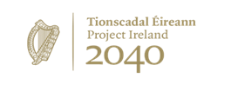
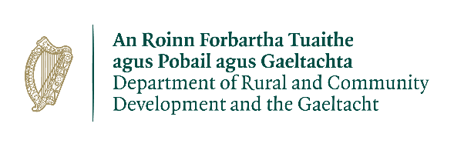
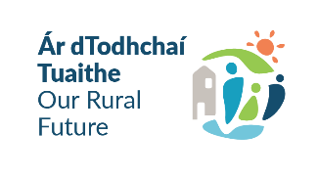

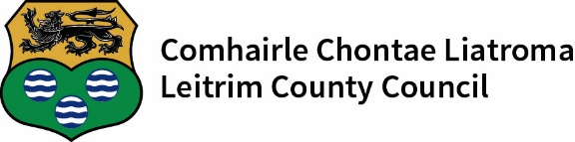

Expression of Interest Form
Town & Village Renewal Scheme 2026
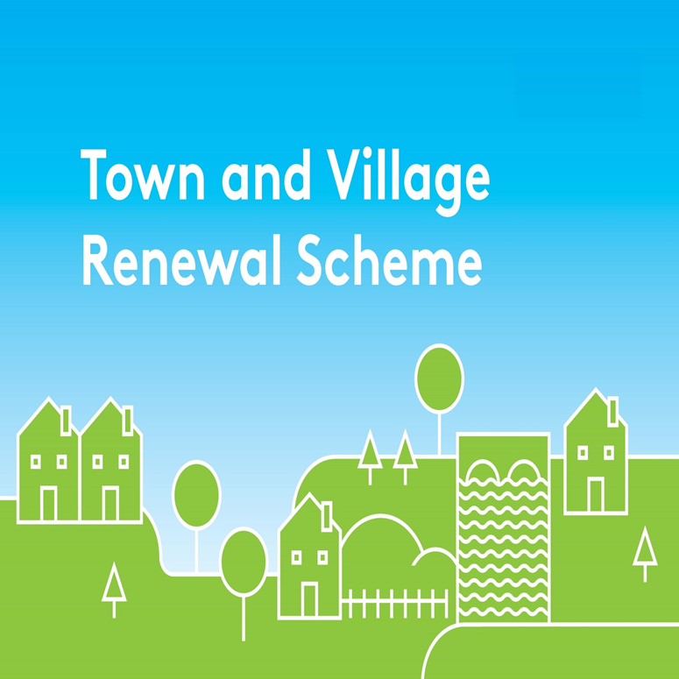

Please complete this Expression of Interest form
and return it to funding@leitrimcoco.ie
Closing Date - Friday 4th December 2026

Town/Village covered:

Please indicate which Measure you are applying for:

Town and Village Town and Village Project Development

Main Scheme Main Scheme Measure

€50,000 to €299,000 €300,000 to €500,000 Up to €50,000

Amount of Funding Requested:

Applicant Group:

Applicant Contact Name:

Applicant Contact Address:

Applicant Telephone Number:

Applicant Mobile Number:

Applicant Email Address:

Please refer to Application Scoring Framework when filling in this EOI.
Available at the end of this document.

- Has funding for this project ever been sought from other sources? Yes No
(If "YES" yes please specify from what source and if funding was provided)

- Who are the specific project stakeholders/community partners in this project?
(Chamber of Commerce, Community group, etc.).

- Project Details:

4. Permissions and Planning
(a) Does the proposed project involve works to a building/property or lands that are not in the ownership of the Local Authority or Local Community Partner? If yes, provide details of the current owner/s.

(b) If the building/property is not in the ownership of the Local Authority or community group partner, has permission has been granted by the owners to carry out the proposed works? A lease must be in place at project commencement date and for a minimum of 15 years from project completion date. Is this in place?

(c) Are all appropriate assessments, screenings and planning permissions in place?

- (a) Please provide details of the community consultation/engagement with local groups and stakeholders to develop this application.

- If seeking funding of between €300,000 and €500,000, please detail the particular case for this level of funding. (This question applies to applications under the Main Scheme only)

- What is the objective of the proposed project and how will the intended outcomes be measured? (Please identify any metrics or benchmarks that will be applied).

- Who will be implementing the project? Please provide details of other stakeholders involved.

- Timeline:
Provide a timeline for commencement and completion of the project.
Any project that has not commenced by the end of the agreed 18 month timeframe will automatically be decommitted.

Commencement Date | Completion Date | Indicative Time Frame (weeks/months):
- Project Costings:
Please provide a detailed breakdown of all elements of the proposed works including any professional fees/costs/signage etc : (please add additional rows for costs as required)

Refer back to the Application Scoring Framework at the end of this form.

Project Element | Estimated Cost (inclusive of VAT)
1. e.g. signage | €
2. | €
3. | €
4. | €
Total Project Cost | €
Grant Aid amount sought:  (Max of 90% of total project costs, 95% for NW Region counties) | €
Match Funding: (Min 10% of total cost, 5% for NW Region counties)  To be supplied by: | €

The fully completed Expression of Interest form should be returned to Leitrim County Council by Friday 4th December 2026 at 4pm to funding@leitrimcoco.ie. Any queries should be directed to 071-9620005 ext 494.

Signed on behalf of _________________________________ (Community Group)

Signature _________________________________________

Name in Block Capitals_______________________________

Position___________________________________________

Date______________________________________________

Application Scoring Framework
