


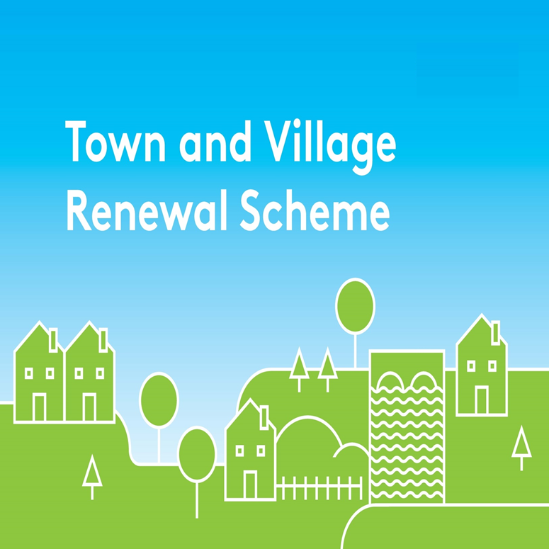

2026 Expression of Interest Form
Building and Land Acquisition Measure (BLAM)
All queries should be addressed to: funding@leitrimcoco.ie

EXPRESSION OF INTEREST FORM

This form should be completed by the Community Group and returned by e-mail to funding@leitrimcoco.ie by 4pm on 15th May 2026.

Name of Community Group:

Amount of Grant Funding Requested:

Contact Name:

Contact email address:

Contact phone No:

Proposal Details:

Q1. Please provide the address of building or land (including Eircode) to be purchased and sale price, together with folio number. (If there is a current for sale advertisement online please provide a link to the ad, and provide a photograph of the building or land). Building/s or land put forward must be available to the market for acquisition in 2026 and there must be clear title provided.

Q2. Please provide a brief background to the selected building or land. Is it vacant and/or derelict? How long has it been vacant? Prior uses, etc. (Max 500 words):

Q3. What is the Community Groups plan for the building or land? Is the planned usage in line with Town and Village Scheme priorities, tackling vacancy and dereliction in towns and villages by repurposing such buildings into multi-purpose community spaces. Are any proposed works, following purchase, achievable within the framework set out in the measure outline? (Max 800 words):

Timeline:

The Building Land Acquisition Measure is strictly only available for application and drawdown in 2026. Leitrim County Council reserves the right not to proceed with this Scheme in the event that the EOIs received do not identify potential quality projects with sustainable, achievable and definitive end uses.

Please ensure that this form is fully completed as an incomplete application may result in the project not being considered.

Completed forms should be returned by e-mail to: funding@leitrimcoco.ie by 15th May 2026 at 4pm.

Please state project name, year and applicant name in the Subject Box (e.g. T&V BLAM 2026 – Leitrim County Council)

Signed on behalf of: _________________________________________ (Community Group)

Signature: _________________________________________

Name in Block Capitals: __________________________________________

Position: __________________________________________

Date: __________________________________________

