**Expression of Interest Form**

**Town & Village Renewal Scheme 2025**

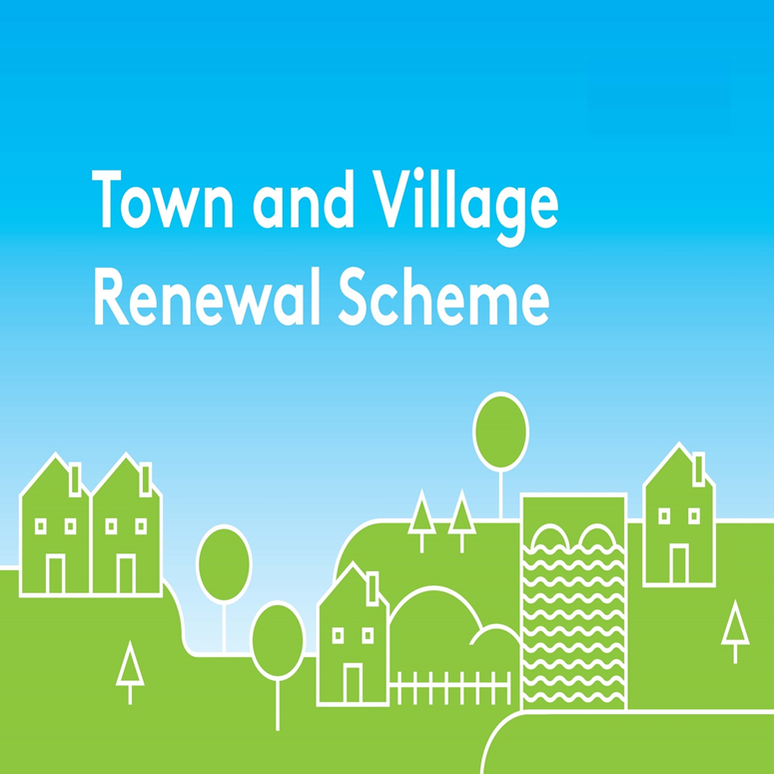

Please complete this Expression of Interest form

and return it to [**funding@leitrimcoco.ie**](mailto:funding@leitrimcoco.ie)  
Closing Date - **Friday 6th June 2025**

**Town/Village covered:**

**Please indicate which Measure you are applying for:**

**Town and Village Town and Village Project Development**

**Main Scheme Main Scheme Measure**

**€50,000 to €300,000 €300,000 to €500,000 Up to €50,000**

**Amount of Funding Requested:**

**Applicant Group:**

**Applicant Contact Name:**

**Applicant Contact Address:**

**Applicant Telephone Number:**

**Applicant Mobile Number:**

**Applicant Email Address:**

1. **Has funding for this project ever been sought from other sources?**  Yes  No

**(If "YES" yes please specify from what source and if funding was provided)**

|  |
| --- |
|  |

1. **Who are the specific project stakeholders/community partners in this project?**

**(Chamber of Commerce, Community group, etc.).**

|  |
| --- |
|  |

1. **Project details:**

|  |
| --- |
|  |

**4. Permissions and Planning**

**(a)** Does the proposed project involve works to a building/property or lands that are not in the ownership of the Local Authority or Local Community Partner? If yes, provide details of the current owner/s.

**(b)** If the building/property is not in the ownership of the Local Authority or community group partner, has permission has been granted by the owners to carry out the proposed works? A lease must be in place at project commencement date and for a minimum of 15 years from project completion date. Is this in place?

**(c)** Are all appropriate assessments, screenings and planning permissions in place?

1. **(a) Please provide details of the community consultation/engagement with local groups and stakeholders to develop this application.**

|  |
| --- |
|  |

1. **If seeking funding of between €300,000 and €500,000, please detail the particular case for this level of funding. (This question applies to applications under the Main Scheme only)**

|  |
| --- |
|  |

1. **What is the objective of the proposed project and how will the intended outcomes be measured? (Please identify any metrics or benchmarks that will be applied).**

|  |
| --- |
|  |

1. **Who will be implementing the project?** Please provide details of other stakeholders involved.

|  |
| --- |
|  |

1. **Timeline:**

Provide a timeline for commencement and completion of the project.

Any project that has not commenced by the end of the agreed 18 month timeframe will automatically be decommitted.

|  |  |  |
| --- | --- | --- |
| Commencement date | Completion Date | Indicative time frame (weeks/months): |
|  |  |  |

1. **PROJECT COSTINGS:**

Please provide a detailed breakdown of **all elements** of the proposed works including any professional fees/costs/signage etc : (please add additional rows for costs as required)

**Refer back to the Application Scoring Framework of the Scheme Outline for guidance**.

|  |  |
| --- | --- |
| **Project Element** | **Estimated Cost (inclusive of VAT)** |
| **1. e.g. signage** | € |
| **2.** | € |
| **3.** | € |
| **4.** | € |
| **Total Project Cost** | € |
| **Grant Aid amount sought:**  (Max of 90% of total project costs, 95% for NW Region counties) | € |
| **Match Funding: (Min 10% of total cost, 5% for NW Region counties)**  **To be supplied by:** | € |

The fully completed Expression of Interest form should be returned to Leitrim County Council by **Friday** **6th June 2025** at 4pm to funding@leitrimcoco.ie. Any queries should be directed to 071-9620005 ext 496 or 661.

Signed on behalf of _________________________________ (Community Group)

Signature _________________________________________

Name in Block Capitals_______________________________

Position___________________________________________

Date_____­­­­­­­­­­_________________________________________