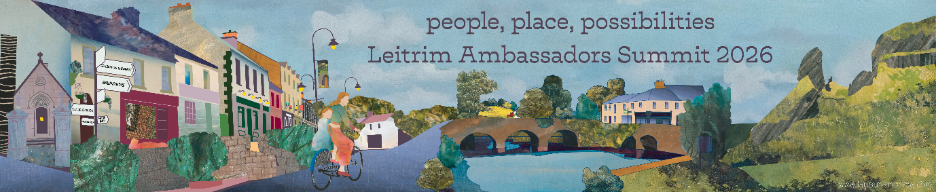
People, Place and Possibilities: Why Leitrim's Future Is Being Shaped Now
Most Definitely Leitrim
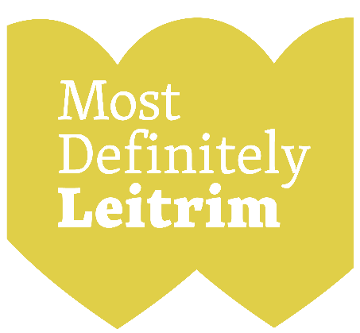
Across local government, we often speak about opportunity, resilience and transformation. Yet there are moments when several strands come together at once and create the conditions for genuine change. There are moments in the life of a county when individual projects, investments and initiatives begin to form something much bigger than the sum of their parts. For Leitrim, this is one of those moments, and part of the build-up has included:
National Broadband Plan
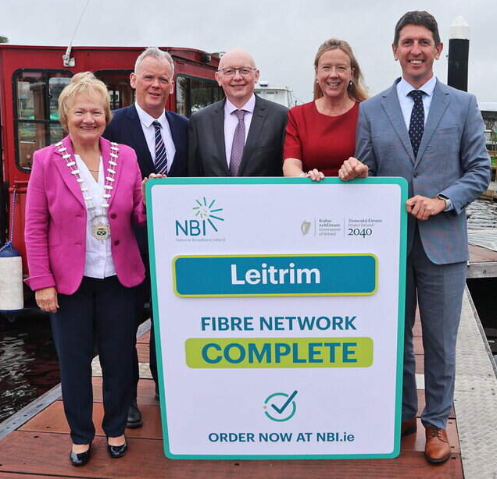
The recent completion of National Broadband Plan connectivity throughout the county represents another transformative step, ensuring that homes, businesses and communities can participate fully in an increasingly digital economy. National confidence in the County was subsequently reflected recently by Minister Browne, who recently announced over €13m worth of investment in Carrick on Shannon through the Town & Cities Fund.
Economic and Skills Strategy
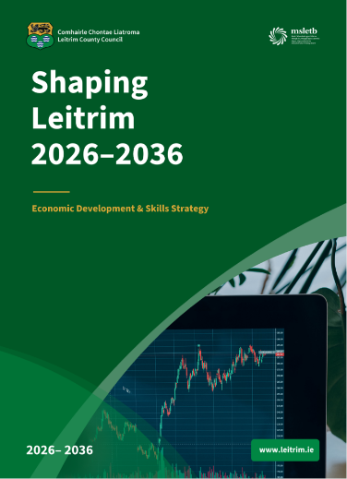
The launch of our new Economic and Skills Strategy reinforces this ambition. It sets out a vision for a county that is well connected, skilled, entrepreneurial and outward-looking. A place that can attract investment, support business growth and provide opportunities for people to build successful careers while enjoying an exceptional quality of life. This is the context in which we are hosting the Leitrim Ambassadors Summit.
Leitrim Ambassadors Summit 2026
The inaugural Leitrim Ambassadors Summit 2026 being held on the 24th and 25th September brings together leaders from business, government, education, culture, community organisations and our global diaspora, not simply to reflect on what has been achieved, but to explore what comes next.
At its core, the summit is about connection. It is about strengthening relationships, sharing ideas and building partnerships that can help unlock future opportunities for Leitrim. It is also an opportunity to showcase the confidence that exists across the county today. Confidence built on real progress, real investment and real ambition.
As part of the summit, we are excited to launch the following new promotional film that captures a vision of future Leitrim. It tells the story of a place that is evolving while remaining true to itself. A place where people can innovate, start businesses, pursue careers, raise families and enjoy a quality of life that is increasingly sought after but often difficult to find. Most importantly, it tells the story of the people who are making that future happen.
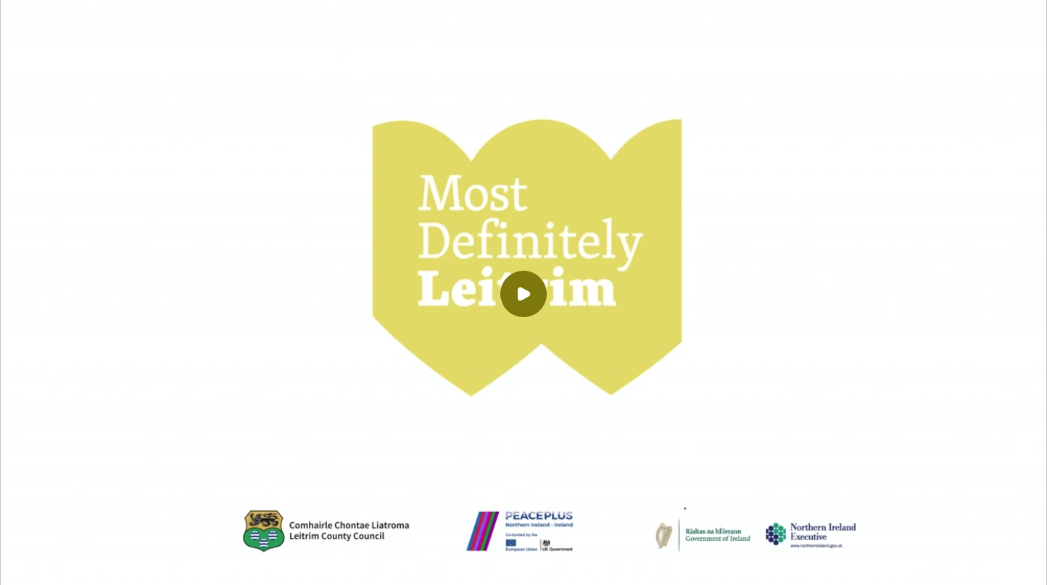
That belief sits at the heart of our Most Definitely Leitrim message. It is both a statement of confidence and a declaration of intent. It reflects a county that is proud of its heritage but ambitious for its future. A county that combines creativity with enterprise, innovation with community, and quality of life with economic opportunity. For too long, rural places have often been defined by what they lack. Leitrim's experience tells a different story. We see a county rich in talent, ideas and potential. We see entrepreneurs creating new businesses, communities driving local change, artists and innovators bringing fresh perspectives, and young people who want to play a role in shaping the future of the place they call home.
Thank you for choosing Leitrim
Balanced regional growth is not simply a policy objective. It is essential to creating a stronger, more resilient and more prosperous Ireland. Leitrim has always been a county of determination, resilience and imagination. Today, we are combining those qualities with investment, connectivity and opportunity. The result is a county that is increasingly confident about its future.
And that future is, most definitely, Leitrim.

