Japanese Knotweed is one of the most problematic invasive alien species and is an increasingly common sight on waste ground, the fringes of our waterways and roads and in our wetland habitats. Japanese knotweed can seriously damage buildings and infrastructure by growing through concrete, tarmac and other hard surfaces if any cracks exist. Japanese knotweed grows vigorously and outcompetes native plants. It forms tall thickets up to 3 metres in height that exclude all other vegetation, shading the area below. The principal means of spread of Japanese knotweed is entirely through the deliberate or accidental movement of rhizome fragments or cut stems. Japanese knotweed has the extraordinary ability to spread and even tiny amounts of cut stem, crown or rhizome are capable of producing a new plant. Controlling spread is therefore dependent on preventing the spread of the stem, crown or rhizome. Landowners are being asked to be on the lookout for Japanese knotweed and cutting back or trimming of Japanese knotweed must be avoided.

**How do you recognise it?**

Japanese knotweed can be identified by its hollow bamboo like stems which are green with red/purple speckles during summer. The leaves are green, shield shaped with pointed tips and a flat base, 10-15cm in length arranged in zig-zag pattern on red shoots off the main stem. It produces off-white coloured flowers in small clusters which and hang from the joint of the stem and the leaf. They flower from August to October. The roots are tough, thick and wood like in their appearance. If snapped they show a bright orange colour inside and have a consistency similar to that of a carrot. New rhizome growth is white in appearance and can be delicate. These root structures can extend up to 7 m in a lateral direction (but usually only up to 5 m), and 2m deep from the over ground parent plant.

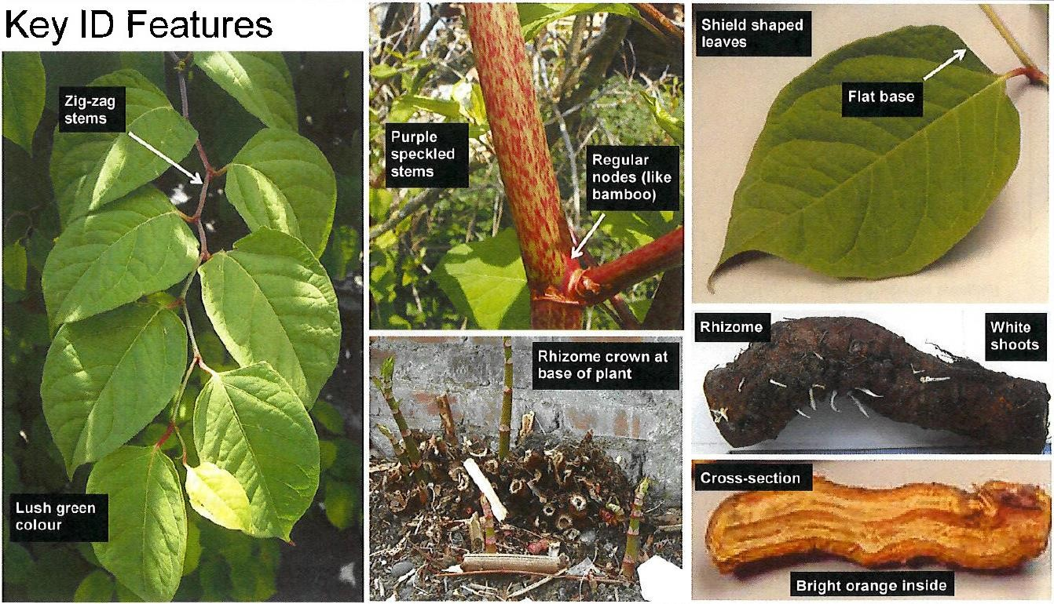

**Can Japanese knotweed or the other invasive knotweed species be confused with any other plant in Ireland?**

Due to its bamboo like stems and dense growth it is sometime confused with bamboo plants or Red dog osier (Cornus sericea). These other plants are however rarely encountered outside of areas where they have been planted and the shape of the leaf and zig-zag leaf arrangement on the stems will distinguish it from these species.

Himalayan knotweed (Persicaria wallichii) can sometimes be confused with Himalayan balsam (Impatiens glandulifera) as they both have their leaves arranged in whorls along the stem. However, Himalayan balsam has toothed leaf edges (like a knife), its stem is very fragile and easily broken and its flowers are very different being larger and ‘bonnet’ shaped and mostly pink to purple.

During the winter season the stems become an orange brown colour which may stay in place for a number of years. The new growth during spring is

indicated by shoots of a red-purple colour with rolled back leaves, growing

**Why should you be concerned?**

Japanese knotweed readily establishes population along roadsides, railways, riverbanks and hedgerows proving to be a driving hazard by blocking sightlines and damaging road surfaces.

* The plant can grow through concrete and tarmac causing dangerous and expensive structural damage. Its persistence means its impact is often felt long-term.
* By establishing itself on riverbanks the plant can affect flood defence structures and increase flood risks.
* Given its vigorous growth rates, it can quickly form tall thickets shading out the areas immediately below it, leading to a loss of native plants, it can leave areas particularly river banks exposed to erosion from heavy rain and flooding.

**What should you do if you find Japanese knotweed?**

If you do find Japanese knotweed on your property it is most important that you prevent further spread of the plant. Do not strim, cut, flail or chip the plants as tiny fragments can regenerate new plants and make the problem even more difficult to manage. It is also advised not to dig, move or dump soil which may contain plant material as this may contribute to its spread.

**I have Japanese knotweed on my land, do I have to get rid of it?**

Yes, you should take action to control and eradicate this plant from your site. By doing nothing it could be considered an offence by ‘allowing’ it to be dispersed or spread. It also makes sense to try and control and eradicate the plant from the site sooner rather than later as the longer it is left to expand and spread, the more resources will be required to deal with it.