As landowners you inadvertently play an important role in the protection of our waters from pollution such as nutrient enrichment. If applicable to you, please take the time to read this information and make yourself aware of good practice when it comes to spreading fertiliser and adherence to buffer zones.

Water Quality, Agriculture and the European Union Good Agricultural Practice (GAP) Regulations
The purpose of the GAP Regulations is to provide a set of measures to ensure the protection of waters, including drinking water sources, against pollution caused by nitrogen and phosphorus from agricultural sources, with the primary emphasis on the management of livestock manures and other fertilisers. The regulations provide controls on farming practices to ensure protection of water quality, including the following:

- Limits on farm stocking rates.
- Maximum nitrogen and phosphorus application rates.
- Prohibited spreading periods preventing the application of organic and chemical fertilisers during more environmentally vulnerable times of the year.
- Minimum storage requirements for livestock manures.
- Requirements regarding maintenance of green cover in tillage lands.
- Set-back distances from waters.

The Nitrates Explanatory Handbook and other information published by DAFM is available here: https://www.gov.ie/en/publication/c9563-rural-environment-sustainability-nitrates/

Organic fertiliser
Organic fertiliser includes livestock manure, dung-stead manure, farmyard manure, slurry, soiled water, silage effluent, spent mushroom compost, sewage sludge, industrial by-products, sludges and residues from fish farms.
Organic fertiliser or soiled water shall not be applied to land within
- 200 metres of an abstraction point for a water scheme which supplies 100m³ or more of water per day or 500 or more persons.
- 100 metres of an abstraction point for a water scheme which supplies 10m³ or more of water per day or serves 50 or more persons.
- 25 metres of an abstraction point not specified in 1 or 2 above.
- 20 metres of a lake shore.
- 15 metres of exposed cavernous or karstified limestone features.
- 5 metres of surface watercourse. This distance is 10 metres for a period of 2 weeks preceding and 2 weeks following the periods when application of fertilizers to land is prohibited.

Farmyard Manure
“Farmyard Manure” means a mixture of bedding material and animal excreta in solid form arising from the housing of cattle, sheep and other livestock excluding poultry;
Where farmyard manure is held in a field prior to land-spreading it shall be held in a compact heap and shall not be placed within
- 250 metres of an abstraction point for a water scheme which supplies less than 10m³ of water per day or serves less than 50 persons.
- 50 metres of an abstraction point not specified in 1 above.
- 20 metres of a lake shoreline.
- 50 metres of exposed cavernous or karstified limestone features.
- 20 metres of any other surface water.

Organic fertiliser, soiled water or chemical fertiliser shall not be applied
- On wet or waterlogged land.
- Land that is flooded or likely to flood.
- On frozen or snow-covered land.
- If heavy rainfall is forecast within 48 hours.
- On land sloping steeply towards rivers, streams, lakes and exposed bedrock.

Prohibited periods for spreading fertilisers to land in Co. Leitrim
- The spreading of Chemical fertiliser is prohibited from the 15th of September to the 31st of January.
- The spreading of Organic Fertiliser other than FYM is prohibited from the 1st of October to the 31st of January.
- The spreading of Farmyard manure (FYM) is prohibited from the 1st of November to the 31st January.

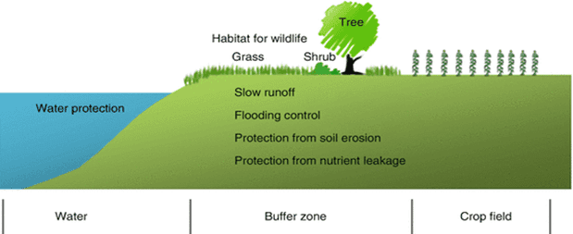
- Create natural buffer zones for waterbodies (as above) where possible on your lands
- If applicable to you adhere to the appropriate GAP set back distances when spreading fertiliser

