Section 38 Road Traffic Act 1994

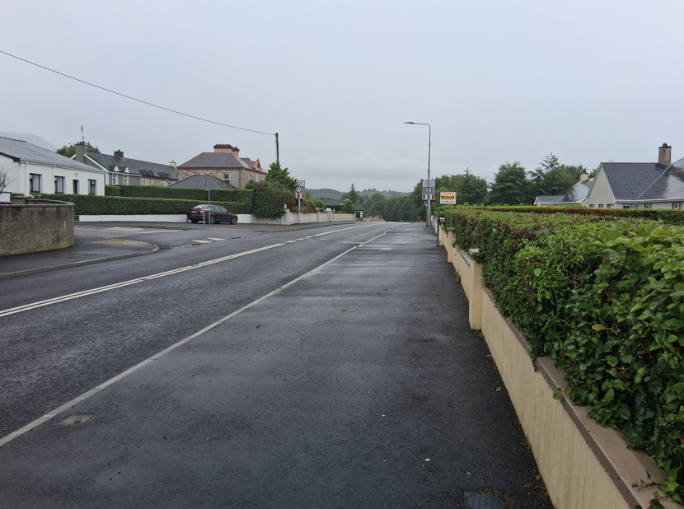

Bus Stop Enhancement Programme 2025
Gubacreeny & Edenvella Townlands, Kinlough, Co. Leitrim.


Table of contents

Introduction 3
Selecting Appropriate Procedure 3
Stage 1: Is Section 38 appropriate? 3
Stage 2: EIA & AA Screening 4
Recording of this Determination 5
Appendix 1 6
Site Location Map 6
General Layout Drawing 7
RUS014 Signage Location Map 8
Appendix 2 9
Guidelines on Traffic Works Procedures 9

Introduction

The purpose of this document is to determine if the works described herein, which are proposed to be carried out by Leitrim County Council Roads Section, are appropriate for assessment and implementation in accordance with Section 38 of the Road Traffic Act 1994. The Department of Transport have published a guidance document on Section 38 procedures, and it sets out the types of works that can be undertaken, processes that apply for permanent works and procedures for temporary or ‘trial’ works. Such processes and procedures allow for consultation and related Traffic Works Orders (Chief Executive Orders).

It is an essential part of this process that there is a Recorded Determination of whether the works
can progress under the provisions of the Section 38 procedure outlined in the Oct 2023 Guidance
Document. This is the record of that determination.

Selecting Appropriate Procedure

Stage 1: Is Section 38 appropriate?

Identify the scope of works and assess if these constitute Traffic Calming Section 38 (9).
As part of the 2025 Active Travel Bus Stop Enhancement Programme, Leitrim County Council intends to improve existing Bus Stops by upgrading existing bus stops and associated public infrastructure, with the primary objective of making the public bus services more accessible, improving passenger experience, comfort and convenience in accordance with the guidelines published by the National Transport Authority (NTA).

The proposed works as detailed on the attached drawing (See Appendix), will consist of the following elements:

- Installation of bus stop road markings and signage poles.
- Installation of 1 No. bus shelter.
- Construction of Zebra crossing to include belisha beacons and new tactile paving.
- Upgrade of public lighting.
- Associated works including surface water drainage, line marking and signage.
- Provision of Road signage including advanced regulatory signage.
- Traffic Management.
- All associated site development works.

On this basis these works fall within the definition of “Traffic Calming” as outlined in Section 38 (9) of the 1994 Road Traffic Act.

Are the proposed measures within boundaries of a public road?
Yes, all the works proposed are within the public realm area which constitutes only the roadway paved areas, and the adjacent public footpaths. All these are classified as part of the public road in accordance with Section 2 of the 1993 Roads Act.

On this basis it can be concluded that Section 38 may be appropriate unless other additional development consents or processes are required.

Stage 2: EIA & AA Screening
EIA Screening
EIAR is not required as the proposed works do not fall into the classification or project thresholds requiring EIAR.

In accordance with EU Directive 2011/92/EU thresholds for which an EIA is required for projects are: -

Annex I projects (EIA required by Directive) are:
“(b) Construction of motorways and express roads,
(c) Construction of a new road of four or more lanes, or realignment and/or widening of an existing road of two lanes or less so as to provide four or more lanes, where such new road or realigned and/or widened section of road would be 10 km or more in a continuous length.”

Annex II projects (Irish requirements specifying thresholds which trigger an EIA),
Includes busway (not bus lanes), service area, new 100m bridge, new 100m tunnel, four-lane road of 500m or more in an urban area and 8 km in a rural area.

Given the nature and size of this project, and its minimal impacts on the environment it can be concluded that an EIA is not required.

AA Screening
The project is located in the Townlands of Gubacreeny & Edenvella in Kinlough, Co. Leitrim.

ITM Coordinates: X = 54.4526 Y = -8.2850.

The nearest Natura 2000 site is Lough Melvin SAC (000428) 0.5 km East of the site. The site gullies will connect to the existing surface water management system, which ultimately discharges into Kinlough Stream, a watercourse directly linked to Lough Melvin. On the basis of the nature and scale of the development proposed, it is considered that there is no potential for significant effects on the Natura 2000 network arising from the proposed works either alone or in combination with other plans and/or projects by way of a loss fragmentation, disruption, disturbance to habitats, species or habitats of species that are of conservation interest.

Stage 3: Planning (Applicability of Part 8 Planning and Development Regs, 2001.)
This project does not exceed the following limits,
- More than €126,000 in value (current estimate is approximately €50k).
- Construction of new or widening or realignment of an existing road greater than 100m, for Urban Area or 1km, for Rural Area.
- Construction of a bridge or tunnel.

Therefore, it can be concluded that the works do not require a Part 8 process in accordance with the Planning and Development Regulations, 2001.

Conclusion

It can therefore be concluded that the proposed works fall within the ambit of Section 38 and no other additional development consents or processes are required.

Therefore, these proposals can be progress under the provisions of the Section 38 procedure outlined in the Oct 2023 Guidance Document, (Included as Appendix 2).

Furthermore, in addition to the consultations outlined in the Guidance Document further consultation in accordance with Section 95 of Road Traffic Act 1961, (requirement to consult with An Garda Siochana) must take place.

As these works are to be in the form of Permanent Works, then the Standard Procedure as outlined in the Section 38 Guidance Document is the appropriate procedure.

Recording of this Determination

It is necessary to record this formal determination of the suitability of Section 38 Procedure and therefore I request that this decision should be recorded in a formal decision record and published on the local authority’s website. This allows the public to become aware that such a decision has been taken in respect of the applicable proposal.

I so recommend,


Michael Guckian
Executive Engineer
Active Travel Department.

Appendix 1

Site Location Map
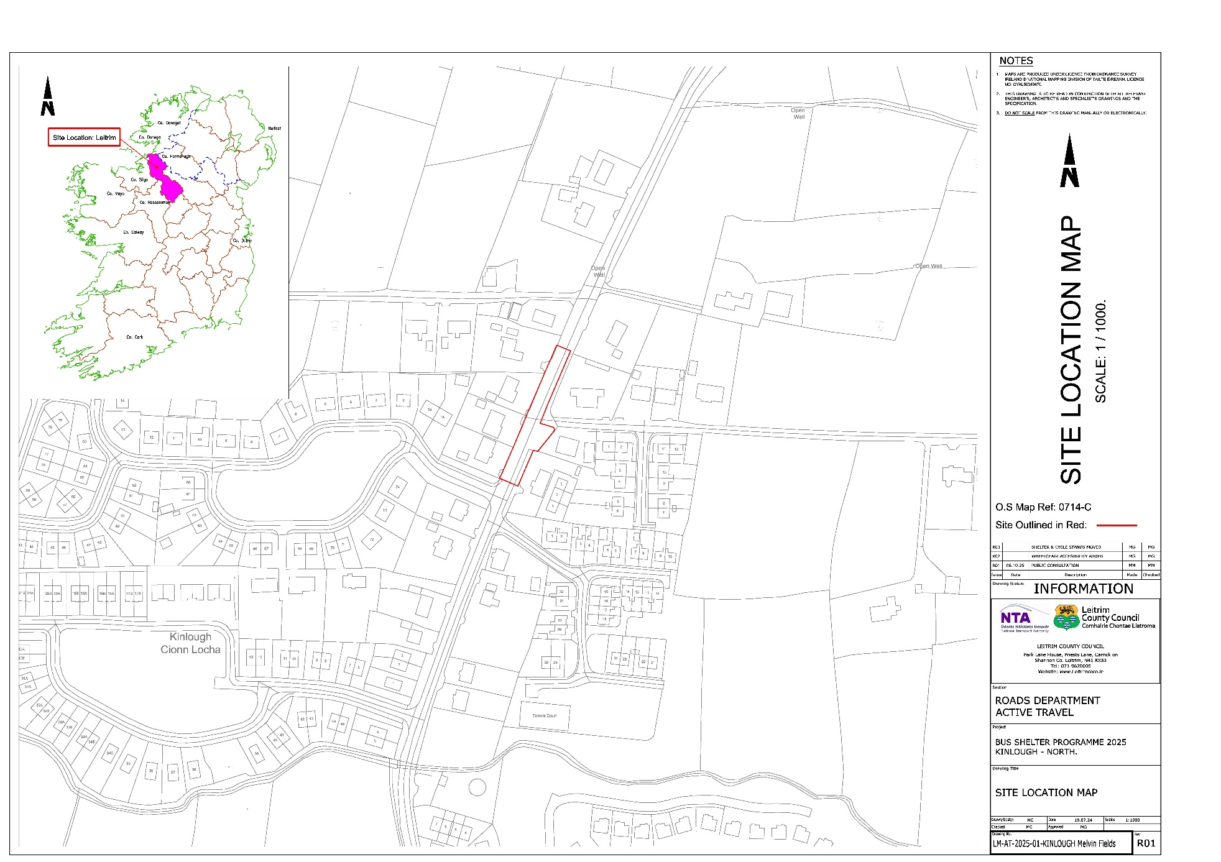

General Layout Drawing

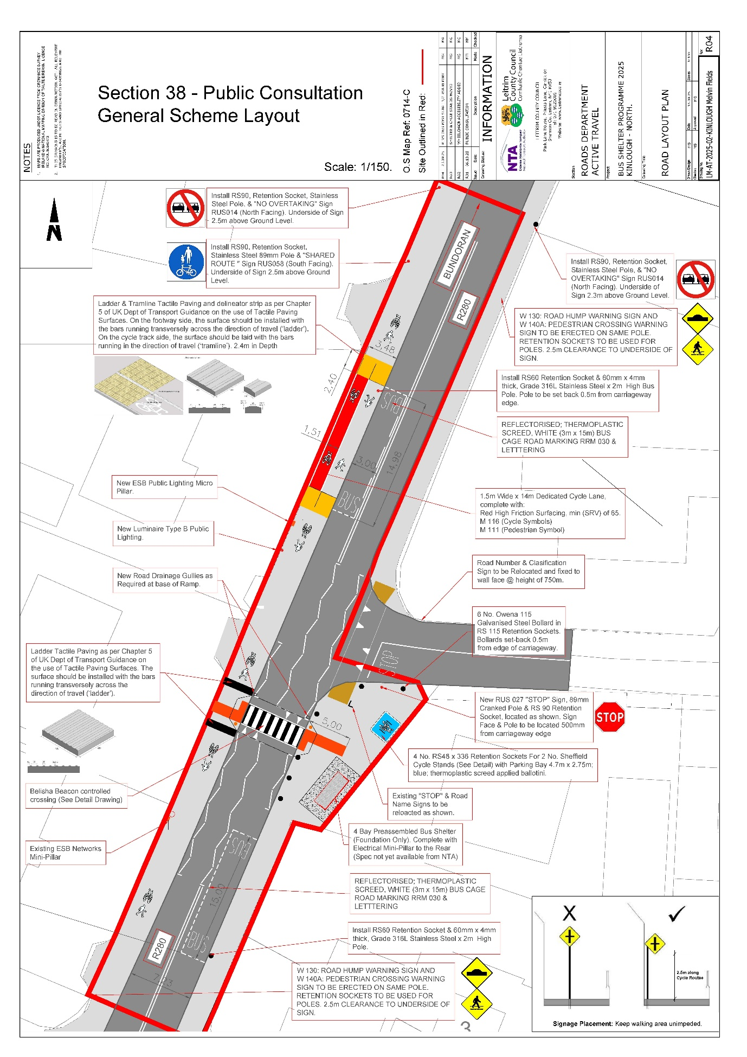

RUS014 Signage Location Map

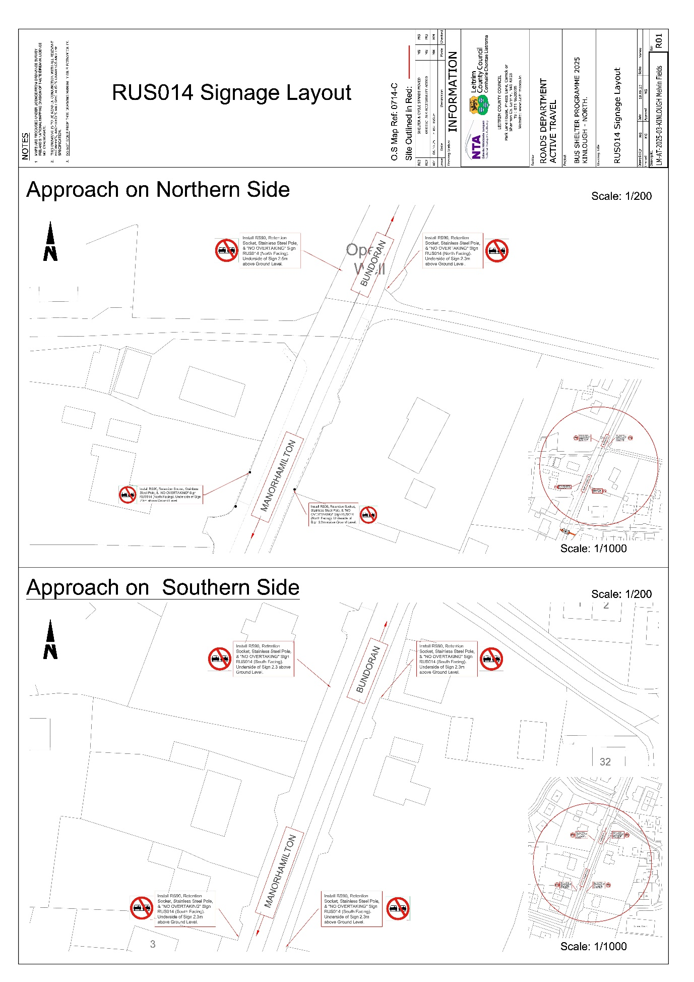

Appendix 2

Guidelines on Traffic Works Procedures
