Declaration under Section 5 of


Planning & Development Act, 2000 (as amended)

To: Justin Fannon, A/Director of Services

From: Joe Duffy – Assistant Planner
Reference No: ED 24-27

Referrer: Leo Rooney
Subject Matter: Declaration under Section 5 of the Planning and Development Act 2000 (as amended) as to whether the upgrade and extension of farm roadway to improve access for livestock feeding and movement is or is not Development and whether it is or is not Exempted Development.
Location Carrickeeny, Manorhamilton, Co. Leitrim.

Date originally

received: 15th August 2024

Date FI response

received: 14th March 2025

- INTRODUCTION
This is a request for a Declaration under Part 1, Section 5 of the Planning and Development Act 2000, as amended, as to whether the upgrade and extension of farm roadway to improve access for livestock feeding and movement is or is not Development and whether it is or is not Exempted Development. The subject site is located in the townland Carrickeeny, Manorhamilton, Co. Leitrim in the open countryside.
This Section 5 application was submitted under the name of Mr. Leo Rooney on the 15th of August 2024. 2 no. satellite aerial view images which lack detail were first submitted with this Section 5 application. No other details or dimension drawings were included which identify the upgrade or extension roadway in terms of either length or width were provided. Notwithstanding, the subject site was found and visited. The subject site is located in a remote and rural area and forms part of an existing farm approximately 8 kilometres west of Manorhamilton and approximately 0.5 kilometres to the north of the N16. The subject site contains an existing elevated metal clad farm structure with an existing farm track adjacent to same. An existing derelict/ruinous dwelling together with an outbuilding is located higher up along the same track. This ruinous dwelling structure itself does not have an Eircode and does not appear to have been occupied for some time. An existing agricultural entrance and laneway already exist at the junction with the minor public road which rises up and extends to the rear and serves the aforementioned agricultural structure. The development, the subject of this Section 5 declaration requests whether the upgrade and extension of farm roadway to improve access for livestock feeding and movement is or is not Development and whether it is or is not Exempted Development. From the drawings originally received, the proposed length, upgrade or indeed the proposed width of this new additional roadway was not stated or provided with this original Section 5 declaration application.

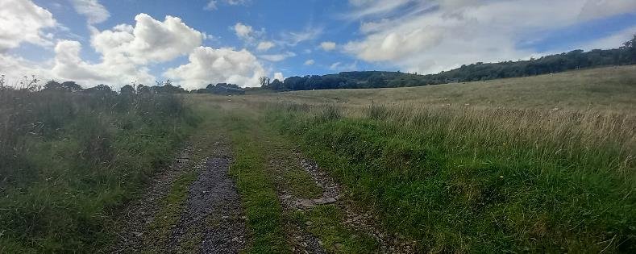
Existing farm laneway with existing operational farm structure and derelict house

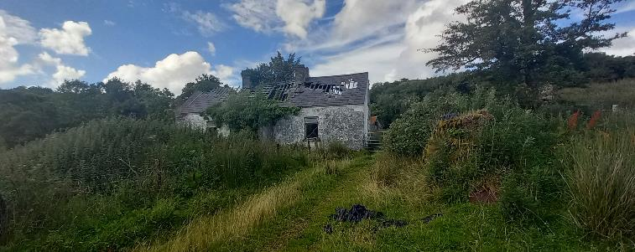
Derelict house

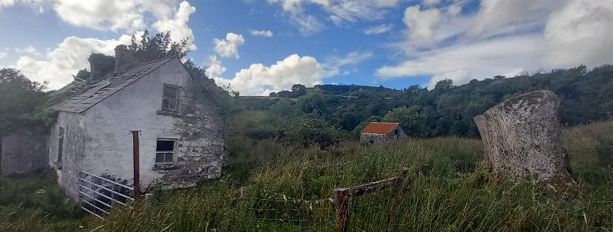
Derelict house and other small structure

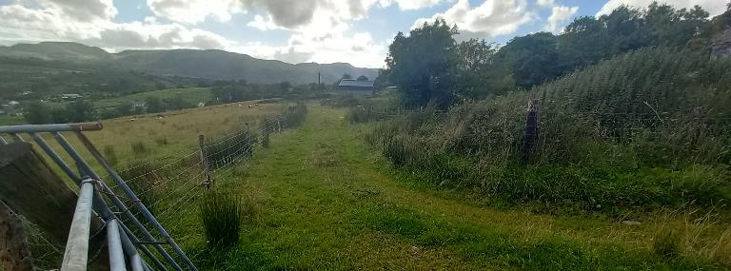
Laneway from derelict house back to agricultural structure

  - The subject site falls in a rural location in the open countryside. The site does not lie within any visually sensitive designated areas or Natura 2000 areas as identified in the Leitrim County Development Plan 2023-2029.

  - FILE HISTORY
I refer to my earlier report dated 15th August 2024 and the following request for further information as issued to the applicant on the 16th August 2024. The applicant’s response, received on the 14th March 2025 is detailed hereunder.

In accordance with the provisions of Section 5(2)(b) of the Planning & Development Act 2000 (as amended), the following further information is required to enable the Planning Authority to issue a declaration:

- Insufficient information has been submitted with this application to allow the Planning Authority make a determination on the submitted matter. You are requested to submit a Site Layout Plan (to a scale of not less than 1:500) clearly identifying the existing farm roadway and the nature of the proposed upgrade and extension of farm roadway in question. The submitted plan shall clearly indicate and distinguish the location and width of both the existing and proposed roadway along with its proposed length of upgrade and extension and also indicate the proposed finish / materials of the upgraded and extended section of roadway.

Advice Note
The Planning Authority would advise that Class 13 of Schedule 2, Part 1 of Exempted Development of the Planning and Development Regulations, 2001 (as amended) provides for the following:

The repair or improvement of any private street, road or way, being works carried out on land within the boundary of the street, road or way, and the construction of any private footpath or paving.

This is qualified by adhering to the condition and limitation whereby the width of any such private footpath or paving shall not exceed 3 metres.

Response
The response to item 1 above includes a labelled aerial/satellite image stated to be of scale 1:500 together with a basic table with sparse details on the extent of the resurfacing proposals of the existing laneway together with a statement on the length, width and surface of the new farm roadway newly labelled A, B, C & D (see hereunder).

- A-B Resurface with 804 aggregrate.
- B-C Proposed width 250cm. Remove topsoil to 30 cm, set down Terram membrane, backfill with 270mm 616 stone (3 inch down), top 30mm with 804 (dust), camber topsoil to limit run off into water pathways.
- C-D Proposed width 250cm. Remove topsoil to 30 cm, set down Terram membrane, backfill with 270mm 616 stone (3 inch down), top 30mm with 804 (dust), camber topsoil to limit run off into water pathways.
- D-A Proposed width 250cm. Remove topsoil to 30 cm, set down Terram membrane, backfill with 270mm 616 stone (3 inch down), top 30mm with 804 (dust), camber topsoil to limit run off into water pathways.

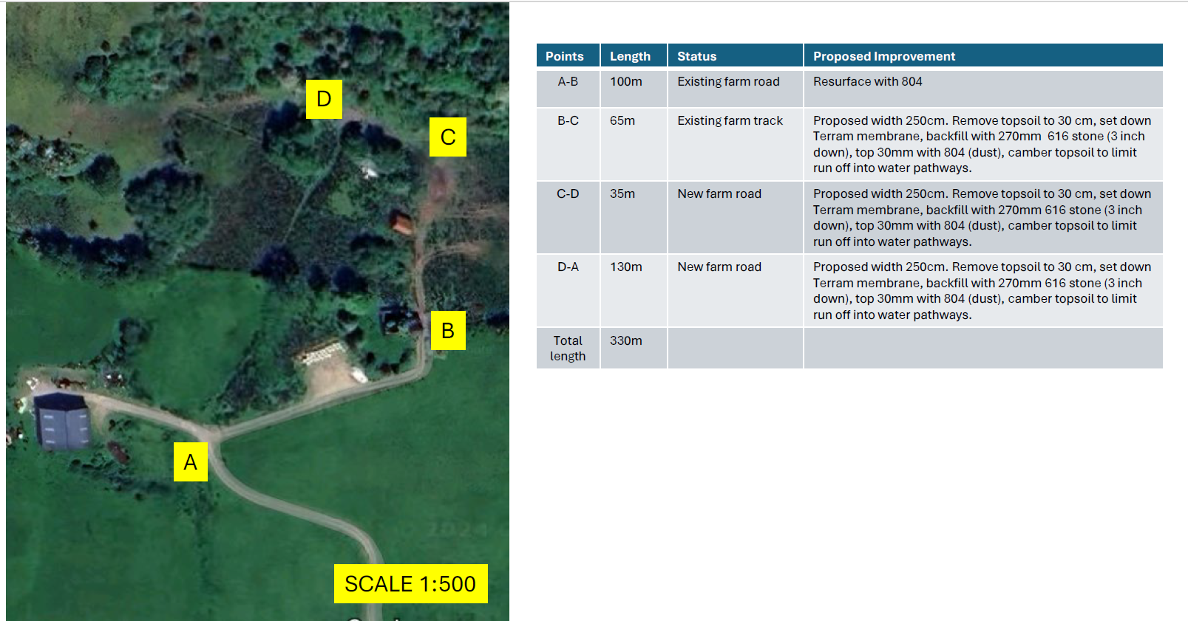

- REFERRAL SUBMISSIONS
  - The subject application was received by the Planning Authority on the 25th July 2024 from Leo Rooney with the Further Information received on 14th March 2025.

  - The request seeks a declaration as to whether the upgrade and extension of farm roadway to improve access for livestock feeding and movement is or is not Development and whether it is or is not Exempted Development. No appropriately scaled drawings with scaled dimensions nor any details on the upgrade proposals are included with this application. A site visit was conducted on the 13th August 2024 (see photos).

- PLANNING HISTORY
None stated.

- RELEVANT LEGISLATION
  - Planning and Development Act, 2000 (as amended)
S.2(1) defines structure as ‘any building, structure, excavation, or other thing constructed or made on, in or under any land, or any part of a structure so defined’

S.3 (1) In this Act ‘development’ means, except where the context otherwise requires, the carrying out of any works on, in, or under land or the making of any material change in the use of any structures or other land.

S.4 (2) (a) The Minister may by regulations provide for any class of development to be exempted development for the purposes of this Act where he or she is of the opinion that—
(i) by reason of the size, nature or limited effect on its surroundings, of development belonging to that class, the carrying out of such development would not offend against principles of proper planning and sustainable development, or
(ii) the development is authorised, or is required to be authorised, by or under any enactment (whether the authorisation takes the form of the grant of a licence, consent, approval or any other type of authorisation) where the enactment concerned requires there to be consultation (howsoever described) with members of the public in relation to the proposed development prior to the granting of the authorisation (howsoever described).

(b) Regulations under paragraph (a) may be subject to conditions and be of general application or apply to such area or place as may be specified in the regulations.

(c) Regulations under this subsection may, in particular and without prejudice to the generality of paragraph (a), provide, in the case of structures or other land used for a purpose of any specified class, for the use thereof for any other purpose being exempted development for the purposes of this Act.

  - Planning and Development Regulations, 2001 (as amended)
Article 6(1) of the Planning and Development Regulations 2001, as amended, states that:
Subject to article 9, development of a class specified in column 1 of Part 1 of Schedule 2 shall be exempted development for the purposes of the Act, provided that such development complies with the conditions and limitations specified in column 2 of the said Part 1 opposite the mention of that class in the said column 1.

Article 9(1) of the Planning and Development Regulations 2001, as amended, identifies restrictions on exemptions. Of relevance in this case would be the following:

(a) if the carrying out of such development would –

(i) contravene a condition attached to a permission under the Act or be inconsistent with any use specified in a permission under the Act

(iii) endanger public safety by reason of traffic hazard or obstruction or road users

(vi), interfere with the character of a landscape, or a view or prospect of special amenity value or special interest, the preservation of which is an objective of a development plan for the area in which the development is proposed or, pending the variation of a development plan or the making of a new development plan, in the draft variation of the development plan or the draft development plan.

Class 13 of Schedule 2, Part 1 of Exempted Development of the Planning and Development Regulations 2001, as amended allows for the following exemption subject to conditions and limitations as set out in column 2;

Sundry Works
CLASS 13
The repair or improvement of any private street, road or way, being works carried out on land within the boundary of the street, road or way, and the construction of any private footpath or paving.

Conditions and limitations as set out in column 2;
The width of any such private footpath or paving shall not exceed 3 metres.

- REVISED ASSESSMENT

  - It is considered that the proposed works constitutes development as defined in Section 3 of the Planning and Development Act, 2000 (as amended).

  - The Planning Authority is aware that a similar case and a previous determination has already been made by the Board that has been reviewed and considered for this assessment - Bord Pleanála Case reference RL12.307371 and Leitrim County Council-Planning Authority Case Reference: ED-19-25. The previous case considered similar issues relating to improving existing private roads and the construction of additional roads. I have considered all relevant exemptions available under the Planning and Development Act 2000 (as amended) and the Planning and Development Regulations 2001 (as amended). The section 5 application is described as ‘whether the upgrade and extension of farm roadway to improve access for livestock feeding and movement’.

  - Having regard to the Further Information now received, the details are clearer and it is now known from these details the exact location, dimensions, materials and specifications that are being proposed and sought for both the upgrade of the existing laneway and the proposed extension to this farm roadway. It is also now known that this proposed new farm roadway will connect to the existing agricultural laneway. From the clarification details now submitted with this Section 5 application, it is considered that this proposal would be in accordance with the Planning and Development Regulations, 2001 (as amended) Class 13 of Schedule 2, Part 1 of Exempted Development as follows:

The repair or improvement of any private street, road or way, being works carried out on land within the boundary of the street, road or way, and the construction of any private footpath or paving.

From the details submitted with the Further Information received, the width, length and specifications of the existing laneway to be upgraded and the new laneway proposed are now included with this Section 5 application. (Sundry Works) Class 13 of Schedule 2, Part 1 of the Planning & Development Regulations 2001 (as amended) applies. It is considered that the development as submitted with this Section 5 application now meets with the conditions and limitations and does not exceed 3 metres in width.

- ENVIRONMENTAL IMPACT ASSESSMENT AND APPROPRIATE ASSESSMENT
Section 4(4) of the Act sets out that development shall not be exempted development if an Environmental Impact Assessment (EIA) or an Appropriate Assessment (AA) of the development is required.

The Planning Authority is satisfied that the subject development would not give rise to significant environmental effects and would therefore not require EIA.

The nearest Natura 2000 site is Ben Bulben, Gleniff and Glenade Complex Special Area of Conservation (SAC Site Code: 000623), which is located approximately 1.5km north of the subject site. Given the nature of the project, it is considered that the subject development would not be likely to have a significant effect individually or in combination with other plans or projects on a European site.

- CONCLUSION
Having examined the proposal and reviewed all of the documents relating to this development, along with the relevant legislation, I conclude that the upgrade and extension of a farm roadway to improve access for livestock feeding and movement is development and is exempted development. Therefore, I recommend that the referrer be advised that the upgrade and extension of a farm roadway to improve access for livestock feeding and movement is development and is exempted development.

RECOMMENDATION
Having regard to the foregoing I recommend that the Planning Authority issue the following Declaration under Section 5 of the Planning and Development Act 2000 (as amended):

WHEREAS a question has arisen as to whether the upgrade and extension of a farm roadway to improve access for livestock feeding and movement at Carrickeeny, Manorhamilton, Co. Leitrim constitutes development which is exempted development

AND WHEREAS the said question was referred to Leitrim County Council by the Leo Rooney on the 25th July 2024 with the additional Further Information as received on the 14th March 2025.

AND WHEREAS Leitrim County Council, in considering this referral, had regard particularly to –

- Section 3(1) of the Planning and Development Act, 2000 (as amended)
- Section 4(1) (h) of the Planning and Development Act, 2000 (as amended)
- Class 13 of Schedule 2, Part 3 of Exempted Development Sundry Works

AND WHEREAS Leitrim County Council has concluded that the upgrade and extension of a farm roadway to improve access for livestock feeding and movement at Carrickeeny, Manorhamilton, Co. Leitrim is development and is exempted development.

NOW THEREFORE Leitrim County Council, in exercise of the powers conferred on it by Section 5 (2)(b) of the 2000 Act, as amended, hereby declares that:

the upgrade and extension of a farm roadway to improve access for livestock feeding and movement at Carrickeeny, Manorhamilton, Co. Leitrim constitutes development which is exempted development.


Joe Duffy
Assistant Planner
Date: 25th March 2025

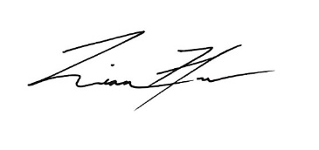

___________________
Liam Flynn
Senior Executive Planner
Date: 25/03/2025

