Declaration under Section 5 of


Planning & Development Act, 2000 (as amended)

To: Emer Connolly, Acting Director of Services

From: Joe Duffy – Assistant Planner
Reference No.: ED 24-27

Referrer: Leo Rooney
Subject Matter Determination under Section 5 of the Planning and Development Act 2000 (as amended) as to whether the upgrade and extension of farm roadway to improve access for livestock feeding and movement is or is not Development and whether it is or is not Exempted Development.
Location Carrickeeny, Manorhamilton, Co. Leitrim.

Date Received: 15th August 2024

- INTRODUCTION
This is a request for a Determination under Part 1, Section 5 of the Planning and Development Act 2000, as amended, as to whether the upgrade and extension of farm roadway to improve access for livestock feeding and movement is or is not Development and whether it is or is not Exempted Development.

This section 5 application was submitted under the name of Mr. Leo Rooney. 2 no. satellite aerial view images which lack detail are submitted with this section 5 application. No other details or dimension drawings are included which identify the upgrade or extension roadway in terms of either length or width are provided. Notwithstanding, the subject site was found and visited. The subject site is located in a remote and rural area and forms part of an existing farm approximately 8 kilometres west of Manorhamilton and approximately 0.5 kilometres to the north of the N16. The subject site contains an existing elevated metal clad farm structure with an existing farm track adjacent to same. An existing derelict/ruinous dwelling together with an outbuilding is located higher up along the same track. This ruinous dwelling structure itself does not have an Eircode and does not appear to have been occupied for some time. An existing agricultural entrance and laneway already exist at the junction with the minor public road which rises up and extends to the rear and serves the aforementioned agricultural structure. The development, the subject of this Section 5 declaration requests whether the upgrade and extension of farm roadway to improve access for livestock feeding and movement is or is not Development and whether it is or is not Exempted Development. From the drawings received, the proposed length, upgrade or indeed the proposed width of this new additional roadway is not stated or provided with this section 5 declaration application.

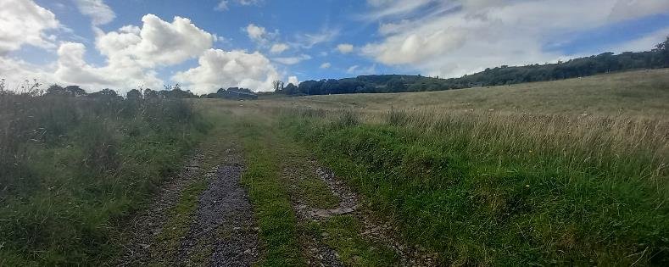
Existing farm laneway with existing operational farm structure and derelict house

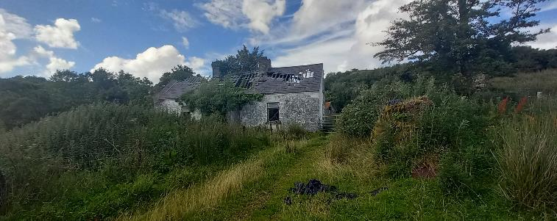
Derelict house

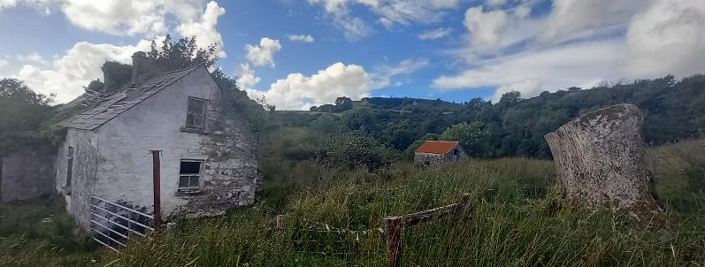
Derelict house and other small structure

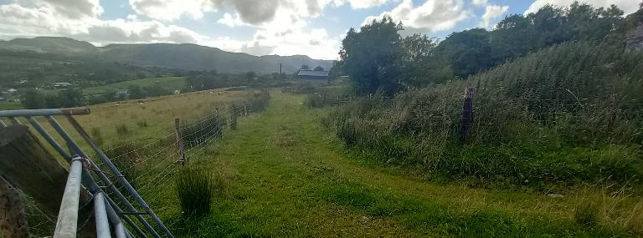
Laneway from derelict house back to agricultural structure

  - The subject site falls in a rural location in the open countryside. The site does not lie within any visually sensitive designated areas or Natura 2000 areas as identified in the Leitrim County Development Plan 2023-2029.

- REFERRAL SUBMISSIONS
  - The subject application was received by the Planning Authority on the 25th July 2024 from Leo Rooney. The request seeks a determination as to whether the upgrade and extension of farm roadway to improve access for livestock feeding and movement is or is not Development and whether it is or is not Exempted Development. No appropriately scaled drawings with scaled dimensions nor any details on the upgrade proposals are included with this application. A site visit was conducted on the 13th August 2024 (see photos).

- PLANNING HISTORY
None stated.

- RELEVANT LEGISLATION
  - Planning and Development Act, 2000 (as amended)
S.2(1) defines structure as ‘any building, structure, excavation, or other thing constructed or made on, in or under any land, or any part of a structure so defined’

S.3 (1) In this Act ‘development’ means, except where the context otherwise requires, the carrying out of any works on, in, or under land or the making of any material change in the use of any structures or other land.

S.4 (2) (a) The Minister may by regulations provide for any class of development to be exempted development for the purposes of this Act where he or she is of the opinion that—
(i) by reason of the size, nature or limited effect on its surroundings, of development belonging to that class, the carrying out of such development would not offend against principles of proper planning and sustainable development, or
(ii) the development is authorised, or is required to be authorised, by or under any enactment (whether the authorisation takes the form of the grant of a licence, consent, approval or any other type of authorisation) where the enactment concerned requires there to be consultation (howsoever described) with members of the public in relation to the proposed development prior to the granting of the authorisation (howsoever described).

(b) Regulations under paragraph (a) may be subject to conditions and be of general application or apply to such area or place as may be specified in the regulations.

(c) Regulations under this subsection may, in particular and without prejudice to the generality of paragraph (a), provide, in the case of structures or other land used for a purpose of any specified class, for the use thereof for any other purpose being exempted development for the purposes of this Act.

  - Planning and Development Regulations, 2001 (as amended)
Article 6(1) of the Planning and Development Regulations 2001, as amended, states that:
Subject to article 9, development of a class specified in column 1 of Part 1 of Schedule 2 shall be exempted development for the purposes of the Act, provided that such development complies with the conditions and limitations specified in column 2 of the said Part 1 opposite the mention of that class in the said column 1.

Article 9(1) of the Planning and Development Regulations 2001, as amended, identifies restrictions on exemptions. Of relevance in this case would be the following:

(a) if the carrying out of such development would –

(i) contravene a condition attached to a permission under the Act or be inconsistent with any use specified in a permission under the Act

(iii) endanger public safety by reason of traffic hazard or obstruction or road users

(vi), interfere with the character of a landscape, or a view or prospect of special amenity value or special interest, the preservation of which is an objective of a development plan for the area in which the development is proposed or, pending the variation of a development plan or the making of a new development plan, in the draft variation of the development plan or the draft development plan.

Class 13 of Schedule 2, Part 1 of Exempted Development of the Planning and Development Regulations 2001, as amended allows for the following exemption subject to conditions and limitations as set out in column 2;

Sundry Works
CLASS 13
The repair or improvement of any private street, road or way, being works carried out on land within the boundary of the street, road or way, and the construction of any private footpath or paving.

Conditions and limitations as set out in column 2;
The width of any such private footpath or paving shall not exceed 3 metres.

- ASSESSMENT
  - It is considered that the proposed works constitutes development as defined in Section 3 of the Planning and Development Act, 2000 (as amended). The Planning Authority is aware that a similar case and a previous determination has already been made by the Board that has been reviewed and considered for this assessment - Bord Pleanála Case reference RL12.307371 and Leitrim County Council-Planning Authority Case Reference: ED-19-25. The previous case considered similar issues relating to improving existing private roads and the construction of additional roads. I have considered all relevant exemptions available under the Planning and Development Act 2000 (as amended) and the Planning and Development Regulations 2001 (as amended). The section 5 application is described as ‘whether the upgrade and extension of farm roadway to improve access for livestock feeding and movement’. However, this description is not very clear and it is unknown from the details received the exact location, dimensions, materials and specifications that are being proposed or sought for this upgrade and extension to this roadway. It is also unknown at this time whether or where this proposed new farm roadway will connect to the existing agricultural laneway. This needs to be provided by the applicant by way of a Further Information request in order to make a full, proper and more complete assessment.

  - From the minimal details submitted with this section 5 application it is not known whether this proposal would be in accordance with the Planning and Development Regulations, 2001 (as amended) Class 13 of Schedule 2, Part 1 of Exempted Development as follows:

The repair or improvement of any private street, road or way, being works carried out on land within the boundary of the street, road or way, and the construction of any private footpath or paving.

It is noted from the details submitted that an agricultural laneway already exists at this location. However, the width and specifications of the existing laneway together with the location of the additional laneway are unknown and are not provided with this application. As such, further details including appropriately scaled drawings are required in order to fully assess and determine whether this proposal can be considered under (Sundry Works) Class 13 of Schedule 2, Part 1 of the Planning & Development Regulations 2001 (as amended). It is considered that this section 5 proposal, subject to further clarification, will need to be assessed further subject to compliance with the conditions and limitations as outlined below.

The width of any such private footpath or paving shall not exceed 3 metres.
Unknown. The upgrade or indeed the width of the new additional laneway was not provided and cannot be measured. With this, it is unknown whether this upgrade or indeed the additional roadway will be greater than or less than 3 metres as stated above. Furthermore, the exact size and scale of the dimensions of the proposed laneway are not known at this time. Further Information is required.

- Screening for Appropriate Assessment (AA) under Natura 2000 Sites
Given the nature of the development, it is considered that the proposed development would not detrimentally affect any Natura 2000 sites. Accordingly an Appropriate Assessment is not required.

- CONCLUSION
Having examined the proposal and reviewed all of the documents relating to this development, along with the relevant legislation, I conclude that the applicant should submit Further Information in relation to the provision of a farm roadway.

Having regard to the above, Further Information is necessary to facilitate an assessment of the referred question as the details submitted are limited and incomplete.

In accordance with the provisions of Section 5(2)(b) of the Planning & Development Act 2000 (as amended), the following further information is required to enable the Planning Authority to issue a declaration:

- Insufficient information has been submitted with this application to allow the Planning Authority make a determination on the submitted matter. You are requested to submit a Site Layout Plan (to a scale of not less than 1:500) clearly identifying the existing farm roadway and the nature of the proposed upgrade and extension of farm roadway in question. The submitted plan shall clearly indicate and distinguish the location and width of both the existing and proposed roadway along with its proposed length of upgrade and extension and also indicate the proposed finish / materials of the upgraded and extended section of roadway.

Advice Note
The Planning Authority would advise that Class 13 of Schedule 2, Part 1 of Exempted Development of the Planning and Development Regulations, 2001 (as amended) provides for the following:

The repair or improvement of any private street, road or way, being works carried out on land within the boundary of the street, road or way, and the construction of any private footpath or paving.

This is qualified by adhering to the condition and limitation whereby the width of any such private footpath or paving shall not exceed 3 metres.


Joe Duffy
Assistant Planner
Date: 15th August 2024


_____________________
Bernard Greene
Senior Planner
Date: 15th August 2024

