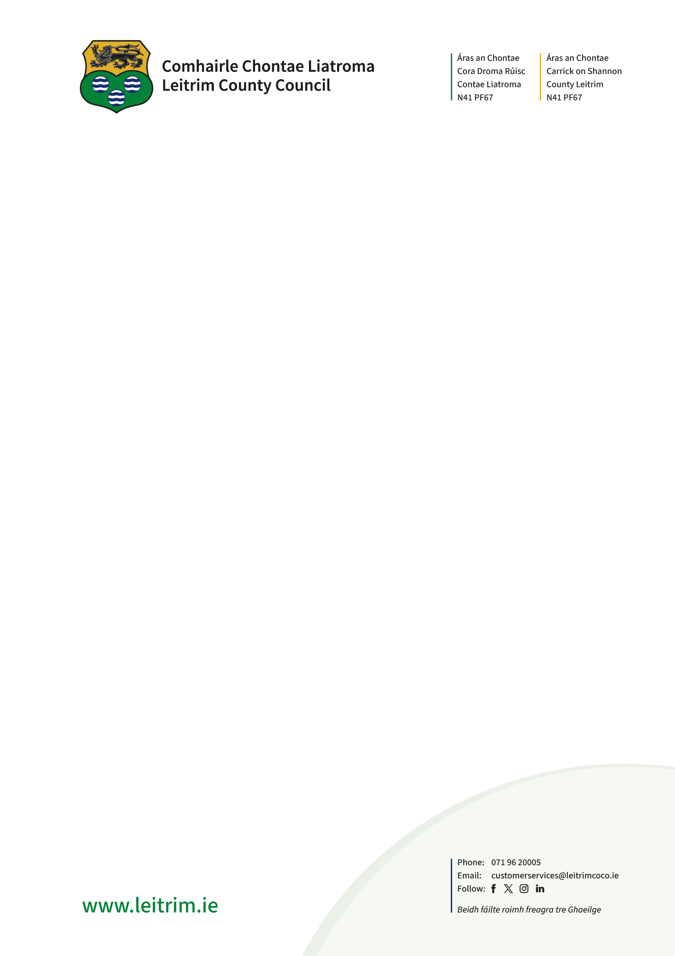

Declaration Regarding Development / Exempted Development
(Section 5 of Planning & Development Acts 2000, As Amended

APPLICATION FORM

1. Name of person seeking declaration [Applicant] _____________________________________

- Postal Address of Property /Site or Building to which the declaration sought relates

______________________________________________________________________

______________________________________________________________________

3 Applicant’s legal interest in the land or structure. [Give details] ___________________________

____________________________________________________________________________

4. State whether or not the applicant is the owner of the property in question [Yes] or [No] and if {No} please provide the information under item 11 at the end of this form

  - State if owner / occupiers are aware of the current application for Declaration under S 5 of the Act [Y] / [N]

  - Type of declaration sought
  - That the proposal is or is not development within the Act [Yes] or [No] and if {yes}
  - That the development is or is not Exempt development [Yes] or [No]

  - Provide full description of the question /matter / subject which arises wherein a declaration on the question is sought? _________________________________________________________
___________________________________________________________________________________________________________________________________________________________________________________________________________________________________________________________________________________________________________________________________________________________________________________________________________________________________________________________________________________________________________________________________________________________________________________________________________________________________________________________________________________________________________________________________________________________________________________________________________________________________________________________________________________________________________________________________________________________________________________________________________________________________________________________________
________________________________________________________________________________________________________________________________________________________________________________________________________________________________________________________________________________________________________________________________________________________________________________________________________________________________________________________________________________________________________________________________________________________________________________________________________________________________________________________

Signature: _____________________________ Date: _________________________________

To give as full account as possible of this matter, the applicant is advised to set out the matter on which the declaration is sought, as comprehensively as possible.

Please submit the following with this application:

- A fee of €80.00
- A site map to a scale of not less than 1;2500 based on the Ordnance Survey map for the area, shall be provided to identify the lands in question
- A site layout map
- Dimension drawings
- A photo / sketch of your proposal

The applicant is advised that notwithstanding the completion of the above application form, that the planning authority may require the applicant to submit further information with regard to the request in order to enable the authority to issue the declaration on the question.

The applicant is also advised that the Authority may also request other persons, other than the applicant to submit information on the question which has arisen and on which the declaration is sought.

FOR OFFICE USE ONLY

Fee of €80.00 Paid. [Yes] / [No]

Decision:

E.O. No and date:

ADDITIONAL CONTACT INFORMATION
NOT TO BE MADE AVAILABLE TO THE GENERAL PUBLIC WITH APPLICATION

Please note:
- The applicant’s address must be submitted on this page.
- If the applicant/agent wishes to submit additional contact information, this may be included here.
- This page will not be published as part of the planning file.

8. Applicant:

Address (Required)
Telephone No.(optional)
Email Address (if any)

Fax No.(if any)

9. Person/Agent acting on behalf of the Applicant (if any):
Name and Address
Telephone No.(optional)
Email Address (if any)
Fax No. (if any)

Should all correspondence be sent to the Agent’s address? (please tick appropriate box)
(Please note that if the answer is ‘No’, all correspondence will be sent to the Applicant’s address)
Yes [ ] No [ ]

10. Person responsible for preparation of any Drawings and Plans accompanying the application:
Name and Address
Telephone No.(optional)
Email Address (if any)
Fax No. (if any)

11. Owner (required where applicant is not the owner):
Name of Owner (Required  Address (required) | ________________________________________________  ________________________________________________  ________________________________________________
Telephone No.(optional)
Email Address (if any)

